Exp. No: 1
Date:

Transformation between Cartesian, Cylindrical and spherical coordinate system

Aim:
To write program for Transformation between Cartesian, Cylindrical and spherical coordinate system using SCILAB.

Software required:
•SCILAB version 6.0.1

Program:
Test case (i) Transformation of Cartesian coordinate points in to Cylindrical and spherical coordinate system

clc;
clear;

x = 4;
y = -5;
z = 11;
r = sqrt(x^2 + y^2);
phi = atan(y, x) * 180 / %pi;
disp("Cartesian to Cylindrical Coordinates (r, phi, z):");
disp([r, phi, z]);
R = sqrt(x^2 + y^2 + z^2);
theta = acos(z / R) * 180 / %pi;
phi = atan(y, x) * 180 / %pi;
disp("Cartesian to Spherical Coordinates (R, theta, phi):");
disp([R, theta, phi]);

Given values:
x = 4;
y = -5;
z = 11;

OUTPUT :

“Cartesian to Cylindrical coordinate system (r, phi, z) = "
6.4031242 -51.340192 11.

"Cartesian to Spherical coordinate system (R, theta, phi) = "
12.727922 30.203779 -51.340192
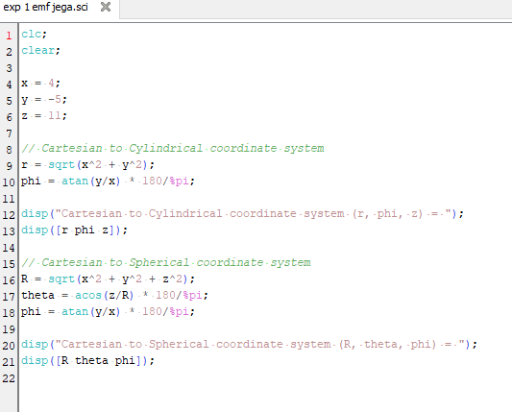
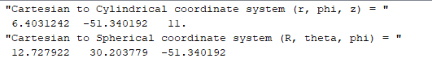
Calculation:

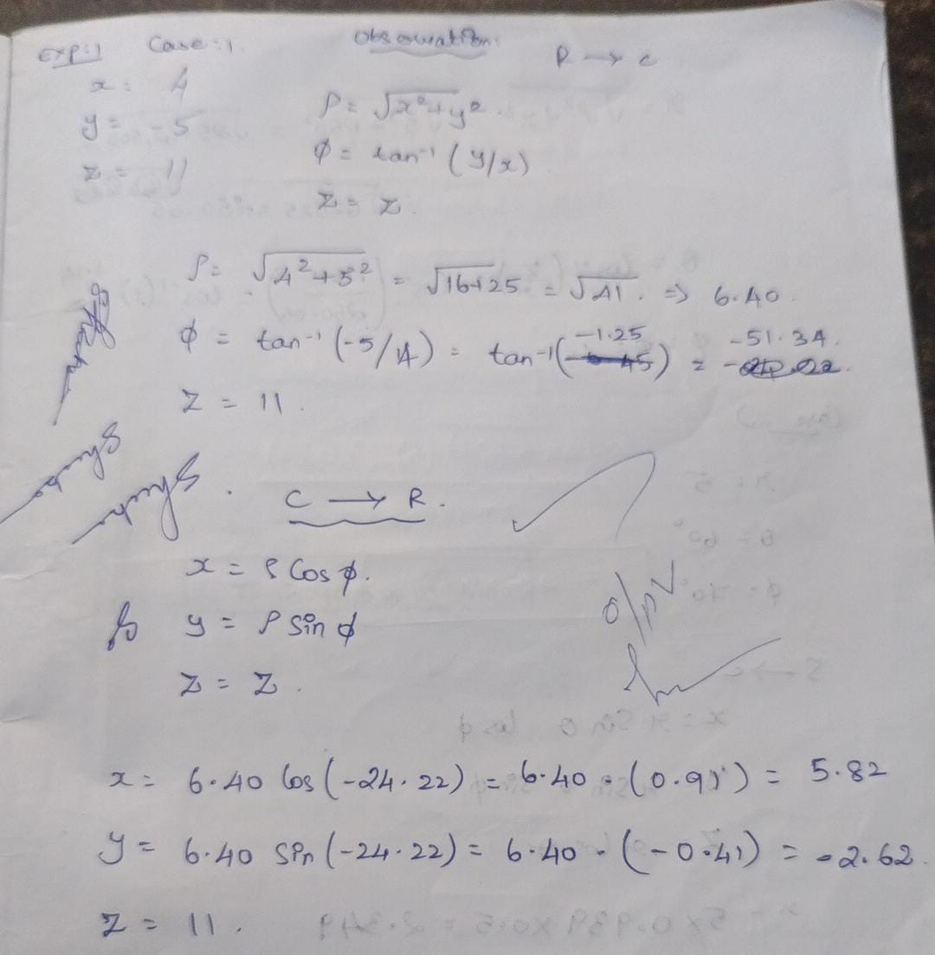

Test case (ii) Transformation of Cylindrical coordinate points into Cartesian and spherical coordinate system

clc;
clear;
r = 5;
phi = 45;
z = 250;
x = r * cosd(phi);
y = r * sind(phi);
disp("Cylindrical to Cartesian coordinate system P(x,y,z) =");
disp([x y z]);
R = sqrt(x^2 + y^2 + z^2);
theta = acosd(z / R);
disp("Cylindrical to Spherical coordinate system S(R,phi,theta) =");
disp([R phi theta]);

Outcome :

Cylindrical to Cartesian coordinate system P(x,y,z) ="
3.5355339 3.5355339 250.
"Cylindrical to Spherical coordinate system S(R,phi,theta) ="
250.05 45. 1.1457628

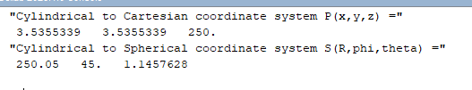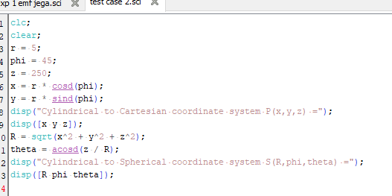
Calculation:

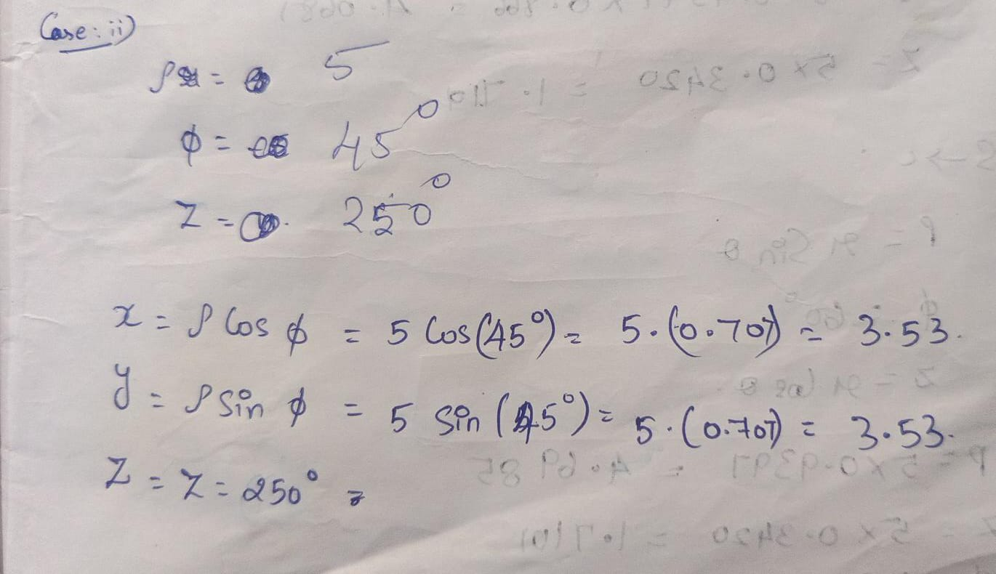

Test case (iii) Transformation of spherical coordinate points into Cylindrical and Cartesian coordinate system

clc;
clear;
r = 5;
phi = 60;
theta = 70;
x = r * sind(theta) * cosd(phi);
y = r * sind(theta) * sind(phi);
z = r * cosd(theta);
disp("Spherical to Cartesian Coordinates (x, y, z):");
disp([x y z]);
rho = r * sind(theta);
phi_cyl = phi;
z_cyl = r * cosd(theta);
disp("Spherical to Cylindrical Coordinates (rho, phi, z):");
disp([rho phi_cyl z_cyl]);

Output :

"Spherical to Cartesian Coordinates (x, y, z):"
2.3492316 4.0689884 1.7101007
"Spherical to Cylindrical Coordinates (rho, phi, z):"
4.6984631 60. 1.7101007
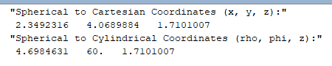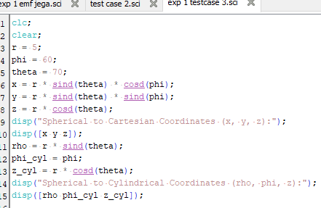

Calculations :
